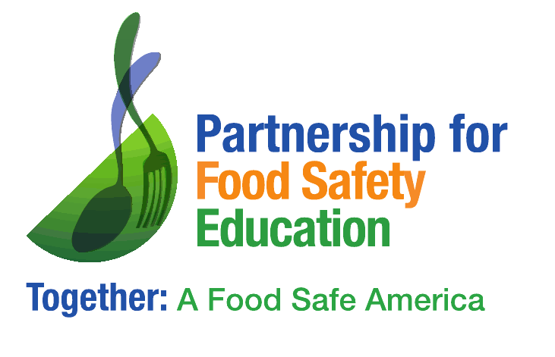

FOR IMMEDIATE RELEASE
June 7, 2020

Contact: Shelley Feist, Partnership for Food Safety Education
sfeist@fightbac.org
w (202) 688-3260
m (202)247-0140

On World Food Safety Day recognizing those who keep us fed
during COVID 19

Washington, DC – People who work to ensure we are fed through the COVID pandemic are being recognized by the non-profit Partnership for Food Safety Education (PFSE) today, the second annual World Food Safety Day.
PFSE organized a social media campaign and created a video, titled “Food Safety Heroes,” to salute these important workers across the country — to thank them and inspire others to promote and protect the public health.
“World Food Safety Day provides an opportunity to celebrate those who are working tirelessly to provide healthy and safe meals,” said Shelley Feist, Executive Director of the Partnership for Food Safety Education. “Whether they are serving food in nursing homes, delivering Meals on Wheels, or working in a food processing plant, we want to show our gratitude to these important people who fuel us with safe food during the COVID-19 pandemic and every day.”
The United Nations has declared June 7, 2020, as World Food Safety Day to draw global attention to the importance of safe food and inspire action to help prevent, detect, and manage foodborne risks worldwide.
View the video here and learn about food safety heroes on Facebook, Twitter and LinkedIn.
foodsafetyday.org/
fightbac.org/
###

The Partnership for Food Safety Education delivers trusted, science-based behavioral health messaging and a network of resources that support consumers in their efforts to reduce risk of foodborne illness. We work with an active network of 13,000 health and food safety educators – we call them BAC Fighters!- and support them by making their work more visible, collaborative, and effective. These BAC Fighters are connecting each year with an estimated 8.5 million consumers –helping them to protect their health through safe food handling and hand hygiene.

