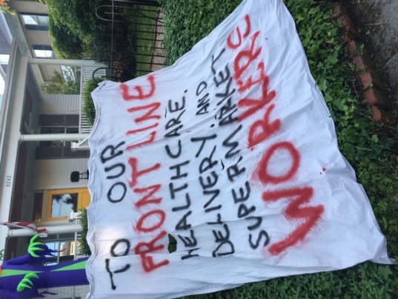
World Food Safety Day 2020
in the United States

Communications initiative of the non-profit Partnership for Food Safety Education

Communications Assets for Partners
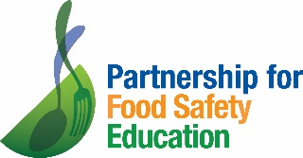
Background: In 2018 the UN General Assembly proclaimed June 7, 2019 as the first World Food Safety Day. The second World Food Safety Day (WFSD) this June 7th will again inspire action to help prevent, detect and manage foodborne risks worldwide.

In the United States, the non-profit Partnership for Food Safety Education is using the opportunity of the 2020 World Food Safety Day to salute the front-line individuals who are working through the COVID-19 pandemic to get food safely to people.

PFSE is producing a salute to those who are working to keep us all fed and healthy.

Between May 19-May 25 PFSE reached out its Partner organizations and its BAC Fighter network urging them to submit recognitions PFSE would use to highlight the everyday heroes in our food system. From the recognitions that were submitted prior to May 26, PFSE is creating an agency-produced salute video.

We know there are thousands of people out there working to feed people and to do so safely! Please plan to create your own World Food Safety Day outreach and events that bring the stories of these great people out for all to see!

YOUR ORGANIZATION – join in for World Food Safety Day
If your organization is interested in joining the food safety hero salute, here are recommendations to get you started:

- Week of May 26 – hold internal conversations on how your organization might want to take part. Check the AVAILABLE ASSETS section for pre-drafted social media posts and images. Build your own outreach using these assets and the hashtags.
- Week of June 1 – watch for PFSE social media (FB, Twitter, and LinkedIn) posts that salute specific people who have been recognized by their communities and their colleagues. Share PFSE posts OR develop your own posts that highlight your own food safety heroes (perhaps employees, people in your community, people your own employees want to salute (food delivery people, or school nutrition people perhaps).
- On June 5-6-7 – please plan to share a scripted, agency-produced compilation video that will salute various people from across the United States who work in schools, food banks, food companies, etc. It will be a video valentine to thank people for the amazing efforts underway to feed people through the COVID19 pandemic.

ABOUT THE VIDEO
On June 4 (late day, eastern time), these videos will be available for you to begin sharing/using/posting leading up to World Food Safety Day (June 7):
- Two 15-30 second videos
- One 60-75 second video

AVAILABLE ASSETS
In addition to the videos described above, the follow assets are available for immediate use: (see attached)
- Social media posts
- Images for social or website posting
- Use foodsafetyday.org to promote the theme of recognizing food safety heroes
- Submit a recognition at foodsafetyday.org
- Promote the recognitions page foodsafetyday.org/recognitions2020
    - This page will show shout-outs of people, including the name of their organization and the state
- An industry press release will be posted on June 4 or 5.

AVAILABLE ASSETS
NOTE: video will be available June 4 for sharing/distribution

Hashtags

#worldfoodsafetyday
#Alonetogether
#foodsafety
#BACFighter
#feedingthenation
#foodsafetyhero

VISUALS
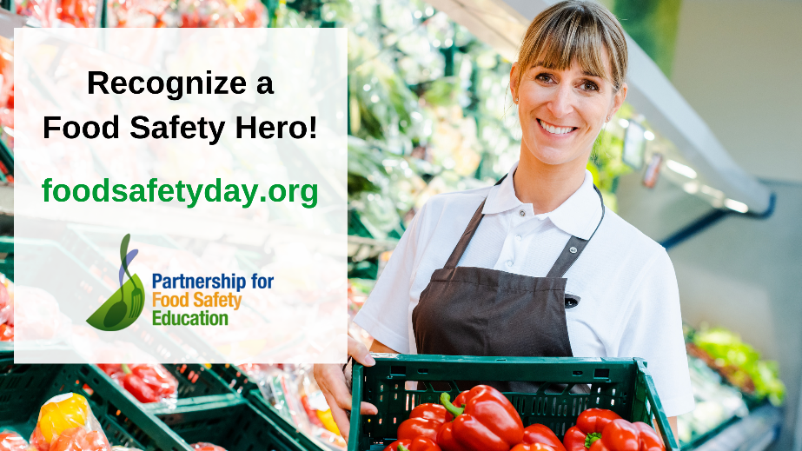

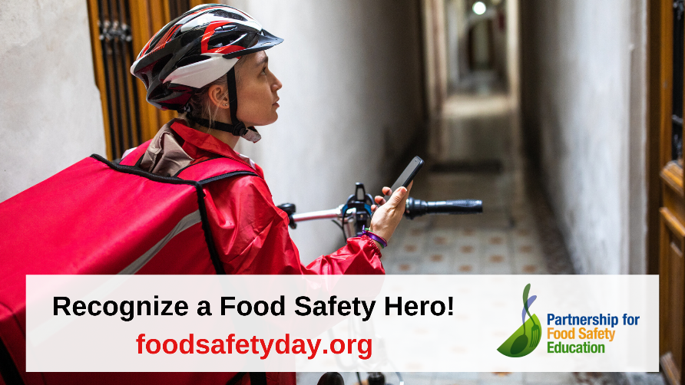

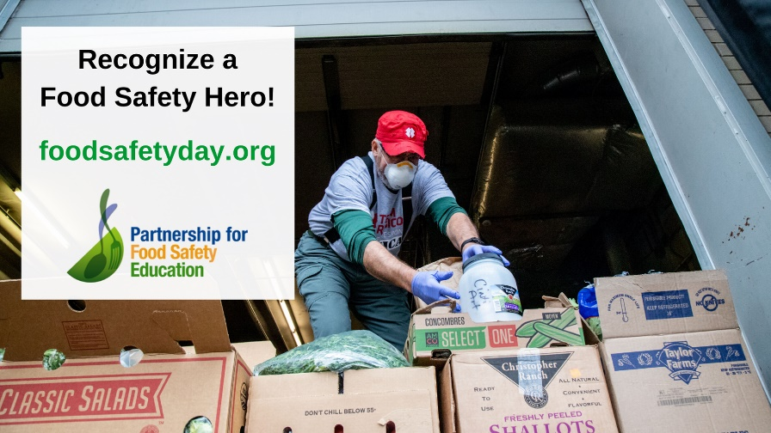

WEEKEND OF WORLD FOOD SAFETY DAY

Social media – please feel free to use these messages !!

(additional social media messages will come out when the video is ready)

Do you know someone who is working tirelessly to keep our food safe? Recognize them by submitting their story to The Partnership for Food Safety Education for a big thank you World Food Safety Day video! https://bit.ly/RecognizeNow
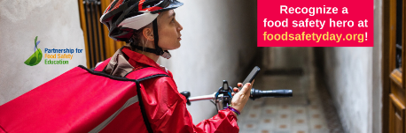

Twitter

Thousands of people have continued to keep our food safe during this pandemic. Show your appreciation by recognizing the food worker in your life for #WorldFoodSafetyDay. Learn More: https://www.foodsafetyday.org/ @Fight_BAC

Help us celebrate all the workers who keep our vulnerable fed and our food safe by sharing the story of a food safety worker in your life for #WorldFoodSafetyDay. Learn More: https://www.foodsafetyday.org/ @Fight_BAC

Everyday frontline food workers are inspiring others. Shine light on their hard work by sharing the story of a food worker in your life: https://www.foodsafetyday.org/ @Fight_BAC #WorldFoodSafetyDay #BACFighter

Food safety workers are critical to ensuring our vulnerable get fed and our food stays safe. Let’s come together to thank these heros for #WorldFoodSafetyDay. Learn More: https://www.foodsafetyday.org/ @Fight_BAC #BACFighter

On #WorldFoodSafetyDay we’re saying thanks to all people who help make sure others are fed. Share the story of a food worker or volunteer you know: https://www.foodsafetyday.org/ @Fight_BAC

Facebook

Help us celebrate all the people who keep our vulnerable fed and our food safe. Share a story of someone who has inspired you to make sure others eat. #WorldFoodSafetyDay. Learn More:https://www.foodsafetyday.org/

Everyday frontline food workers are inspiring others to keep people healthy. Shine light on their hard work by sharing the story of a food worker in your life: https://www.foodsafetyday.org/

Food workers are critical to ensuring our vulnerable get fed and our food stays safe. Let’s come together to thank them by sharing the stories of these heros for World Food Safety Day. Learn More:https://www.foodsafetyday.org/

Join us in saying thank you to the people everyday making sure we are fed safely. Recognize a food safety hero in your life! https://www.foodsafetyday.org/

On World Food Safety Day we’re saying thanks to the people who keep our vulnerable neighbors fed. Join us by sharing a story! https://www.foodsafetyday.org/

LinkedIn

Thousands of food safety workers have continued to keep our food safe during this pandemic. Show your appreciation by recognizing the food worker in your life for #WorldFoodSafetyDay. Learn More: https://www.foodsafetyday.org/

Help us celebrate all the workers who keep our vulnerable fed and our food safe, by sharing the story of a food safety worker in your life for #WorldFoodSafetyDay. Learn More:https://www.foodsafetyday.org/

Everyday frontline food workers are inspiring others to keep people healthy. Shine light on their hard work by sharing the story of a food worker in your life: https://www.foodsafetyday.org/ #WorldFoodSafetyDay

Food workers and volunteers are making sure millions are fed safely during this pandemic. Recognize a food safety hero in your life! https://www.foodsafetyday.org/ #WorldFoodSafetyDay

On #WorldFoodSafetyDay we’re saying thanks to the food safety workers and volunteers helping to keep our vulnerable fed. Join us by sharing the story of a food safety worker you know: https://www.foodsafetyday.org/

PROMOTIONAL or newsletter LANGUAGE

A pandemic is not stopping Food Safety Heroes from making sure people have access to safe food.

To mark World Food Safety Day 2020, the non-profit Partnership for Food Safety Education is highlighting stories of people who are making it possible for their communities to be fed and stay healthy.

Who is your Food Safety Hero? A friend who is working harder than ever at the food bank? The cashier at your neighborhood grocery store? The people at your kids’ school who are distributing free lunches from the parking lot?

Tell everyone about your Food Safety Hero by using this form or by emailing a story or video to us at info@fightbac.org.

Or just go ahead and recognize your Food Safety Hero with a video post on social media (Facebook, Twitter, LinkedIn, Instagram). If you post about someone who is keeping people fed and healthy, we really want to share it! Please use these hashtags so we can look for and share your story far and wide.

#foodsafetyhero
#BACFighter
#worldfoodsafetyday

For more information contact Katie Weston, Community Engagement Manager at kweston@fightbac.org

